**Product Development Laboratory-I**

**Final Evaluation**

**TITLE: “INDOOR TRACKING SYSTEM “**

**Submitted to:**

**Prof. Sujata Mohanty**

**Report Submitted By:**

**1. Sikakollu N V S K Prasanth (116cs0213)**

**2. Uttam Singh (116cs0238)**

**INDOOR POSITIONING SYSTEM**

**Contents:**

1. Introduction
2. Motivation
3. Objective
4. Hardware used
5. Algorithms used
6. Implementation and analysis
7. Conclusion

**Introduction:**

Indoor localization is a fundamental service for various location based applications. Despite the extensive research and development of indoor position systems, location based services are not yet ubiquitous indoors.

Localization of objects or living things or their navigation has always been a primary human concern. Indoor Positioning system can be used to track a person in indoor.

Main challenges of indoor positioning are the limitations of the technologies available. While many existing indoor localization systems are active assemblies based on methods such as ultrasound, radio or optical waves, each of these has its own assets and drawbacks.

Various methods are used for IPS .These include:

1. Using IMU(sensor)
2. Using Wi-Fi finger printing
3. Using Bluetooth Finger printing
4. WLAN or RFID based technologies

Here in this project, we use the IPS with IMU sensor.

**Motivation:**

As the technology has developed day by day, the GPS (Global Positioning System) served the best purpose of localization. The GPS systems fail to track the locations in indoors due to two major

reasons:

1. The GPS localization takes place via microwave radiations and in indoors due to high attenuation through concrete walls, the signals are weakened.
2. The GPS works only when the device supporting the GPS architecture and the satellite are in Line Of Sight (LOS) communication, which is not possible in indoors.
3. GPS system has low precision.

Therefore, when it comes to indoor positioning, other alternatives such as Bluetooth, WI-Fi, RFID and Infrared based techniques.

**Objective:**

The main objective of our project is to track a person inside a large concrete building. This project focuses on integration of low cost Inertial Measurement Unit (IMU) in order to improve the system’s positioning update rate (when compared to other IPS methods) and therefore provide a 2-D localization estimates for kinematic applications.

**Hardware used:**

1. **Inertial Measurement Unit (IMU):**

GY-521 MPU -6050 Module 3 axis Gyro + 3 axis Accelerometer module for Arduino.

In order to determine high-frequency three dimensional positions the six degree of freedom inertial sensor GY521 MPU 6050 consisting of a three axial accelerometer and three axial gyroscope was utilized to observe the user's relative motion with a sample rate up to 256 samples per second.

According to sample rate, the three dimensional acceleration, angular rate and magnetic field are delivered by the IMU. Therefore besides inertial position and orientation it is possible to determine the distances to different reference points

**2. Arduino Board:**

UNO R3 AT mega 328p.

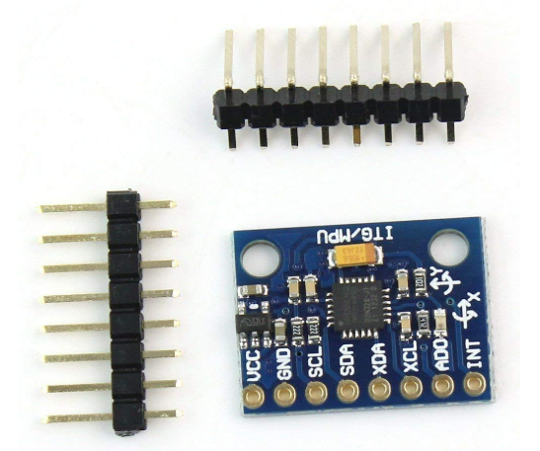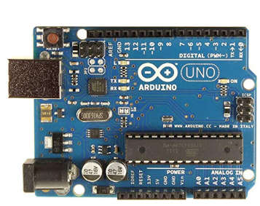

**UNO ARDUINO BOARD**

**6 DOF IMU MPU 6050**

**Algorithms used:**

1. **Kalman filter:**

Kalman filtering, also known as linear quadratic estimation (LQE), is an algorithm that uses a series of measurements observed over time, containing statistical noise and other inaccuracies, and produces estimates of unknown variables that tend to be more accurate than those based on a single measurement alone, by estimating a joint probability distribution over the variables for each timeframe.

The Kalman filter has numerous applications in technology. A common application is for guidance and navigation systems and control of vehicles, particularly spacecraft and aircraft.

The data obtained from IMU is highly affected with noise and if used for prediction may lead to wrong results. So first we preprocess the data by using Kalman Filter. It implements a **predictor-corrector** type estimator that is optimal in the sense that it minimizes the estimated error when presumed conditions are met. The working is shown in the block diagram.

Kalman filter is carried out in two steps:

1. Predict and

2. Update.

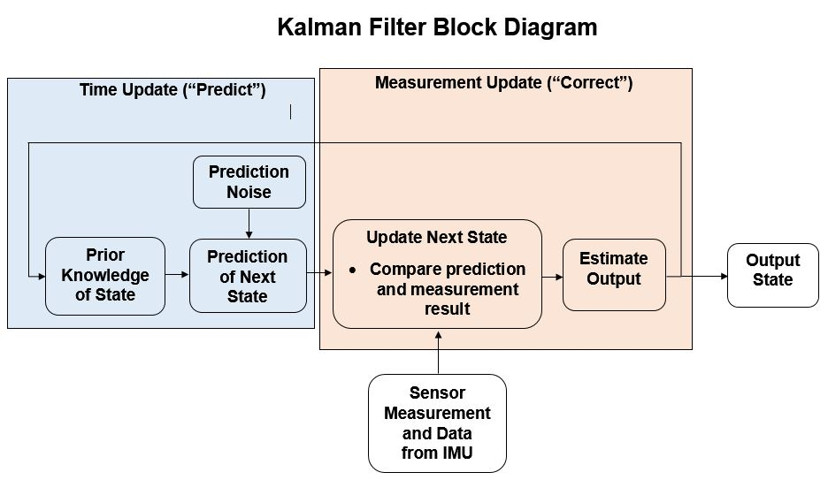

2. **Numerical Integration methods:**

The data obtained from IMU basically gives the accelerations in X, Y and Z co-ordinates but the Kalman filter requires the data of acceleration and velocity. So we use Numerical Integration methods to calculate the velocities and thereby predicting position of the person.

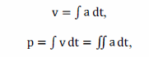

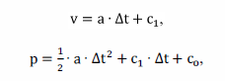

**Project overview:**

Hardware implementation:

1. Interfacing of Arduino board with IMU MPU 6050 was done using Arduino software code.
2. The data obtained from Arduino was exported to the .csv file using software.

**Data Processing:**

Acceleration and angular rates observation of 3 axial IMU sensors are required to achieve high updated two dimensional positioning. For the derivation of system’s complete state, the method of dead reckoning was applied.

**Implementation and Analysis:**

In the prior submission:

The results obtained from Kalman filter were not very much satisfactory, so the work has been extended to implement extended Kalman Filter algorithm to obtain better results for prediction.

Improvement in the final submission:

The extended form of Kalman filter which was used for reduction of noise from the IMU sensor data was implemented and it was observed that the processed data was more accurate and the predictions were less prone to noise and could predict the positions more accurately. Below is the comparison between the plots:

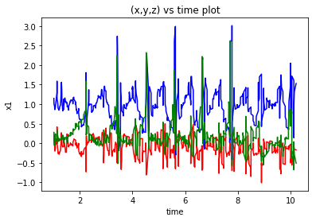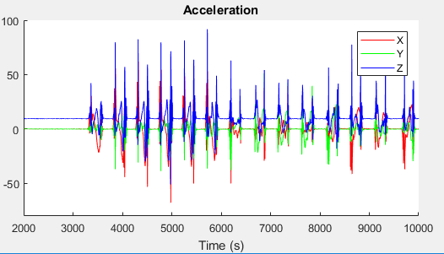

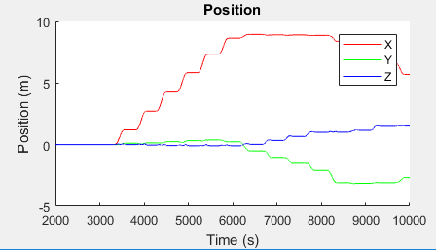

**Result:**

The figure below depicts the implementation of the project “INDOOR TRACKING SYSTEM”. The dataset was collected for climbing up the stairs and predictions were made as below:

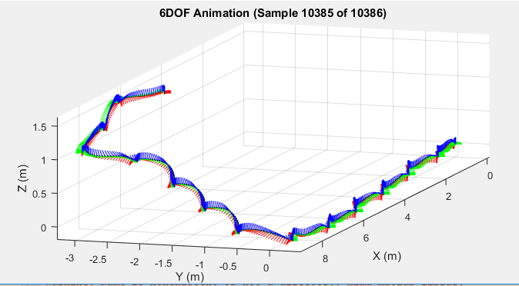

The experimental results have shown that significant increase of trajectory’s accuracy can be reached by using sensor fusion. This knowledge has been used to realize a precise tracking system for indoor movements.

**Conclusion:**

In this contribution, the aim was to present an indoor tracking system for kinematic applications by using low cost IMU. Indoor navigation system has many applications in:

1. Areas of defence
2. To guide a person in a large building
3. To help and guide the people inside the building and rescuing them at times of fire breakdown.

Though the project ends with the tracking of a human, it can be extended to develop an mobile application and clubbed with the A* algorithm of Artificial Intelligence to work as a GPS in indoors.

**\*\*\*\*\*\*\*\*\*\*\*\*\*\*\*\*\*\*THE END\*\*\*\*\*\*\*\*\*\*\*\*\*\*\*\*\*\***